The "Ambiguity Tax" – Quantifying the Impact of Linguistic Ambiguity on LLM Performance
Justin Jiao (justinjiao@g.harvard.edu), Roger Xu (roger560@mit.edu), Ender Yang (enderyan@mit.edu)

Motivation
Natural language is inherently ambiguous — the same sentence can carry multiple valid interpretations depending on context, and human communication routinely relies on shared understanding to resolve this. Code generation tasks are not exempt from this property. Requirements and problem descriptions written in natural language frequently contain ambiguous constructs. When a model encounters such a prompt, it must implicitly commit to one interpretation before generating code, and it typically does so silently, without flagging the ambiguity or seeking clarification. Current code generation benchmarks, designed around well-specified, unambiguous prompts, do not isolate or measure this failure mode. The accuracy cost of ambiguity, and the behavioral patterns that produce it, remain uncharacterized.

Ambiguity is conceptually distinct from underspecification, where a prompt has a single intent but is missing a required constraint; conflating the two obscures the behavioral mechanisms at play, and this study focuses only on ambiguity. Within this scope, we pursue two complementary measurements. First, we quantify the Ambiguity Tax: the reduction in pass@k (Chen et al., 2021) when a model is given an ambiguous prompt relative to a clean, unambiguous version of the same task. Second, we characterize how models behave when facing ambiguity — whether they proceed silently under an implicit assumption, state their assumption explicitly, or seek clarification — providing a systematic behavioral taxonomy that explains where the accuracy loss originates and how it varies across models and ambiguity types.

Proposed Research
We propose building AmbiCode-Eval, a targeted micro-benchmark of 50 carefully curated tasks designed to measure how models navigate ambiguous coding instructions. The 50 benchmark tasks are distributed evenly across 5 ambiguity types (10 per type), each crossed with the risk-level dimension described below.

Variable 1: Linguistic Ambiguity. The instruction is structurally complete but diverges into multiple valid logical interpretations. Drawing from Li et al. (2024), we focus exclusively on the 5 highest-frequency types most disruptive to code generation: Coreferential Ambiguity, Syntactic (Attachment) Ambiguity, Scopal Ambiguity, Collective/Distributive Ambiguity, and Elliptical Ambiguity (See appendix: Ambiguity Definition & Example).

Variable 2: Task Risk Level. We classify tasks as High-Stakes (e.g., data deletion, system state changes) or Low-Stakes (e.g., local string formatting). From preliminary experiments, High-Stakes problems are limited, hand-craft questions may be needed.

Variable 3: Pragmatic Behavior Framework. We evaluate model responses by categorizing them into three distinct behaviors based on HCI risk mitigation:
- Silent Assumption (SA): The model blindly guesses the intent and directly generates code without explanation.
- Explicit Assumption (EA): The model states its assumed premise before generating code (e.g., "Assuming ascending order...").
- Active Clarification (AC): The model pauses code generation entirely to ask the user for missing context.

The optimal behavior is risk-conditional: EA is sufficient for Low-Stakes tasks where a wrong assumption is cheaply corrected, while AC is strictly required for High-Stakes tasks where an incorrect silent assumption can have irreversible consequences.

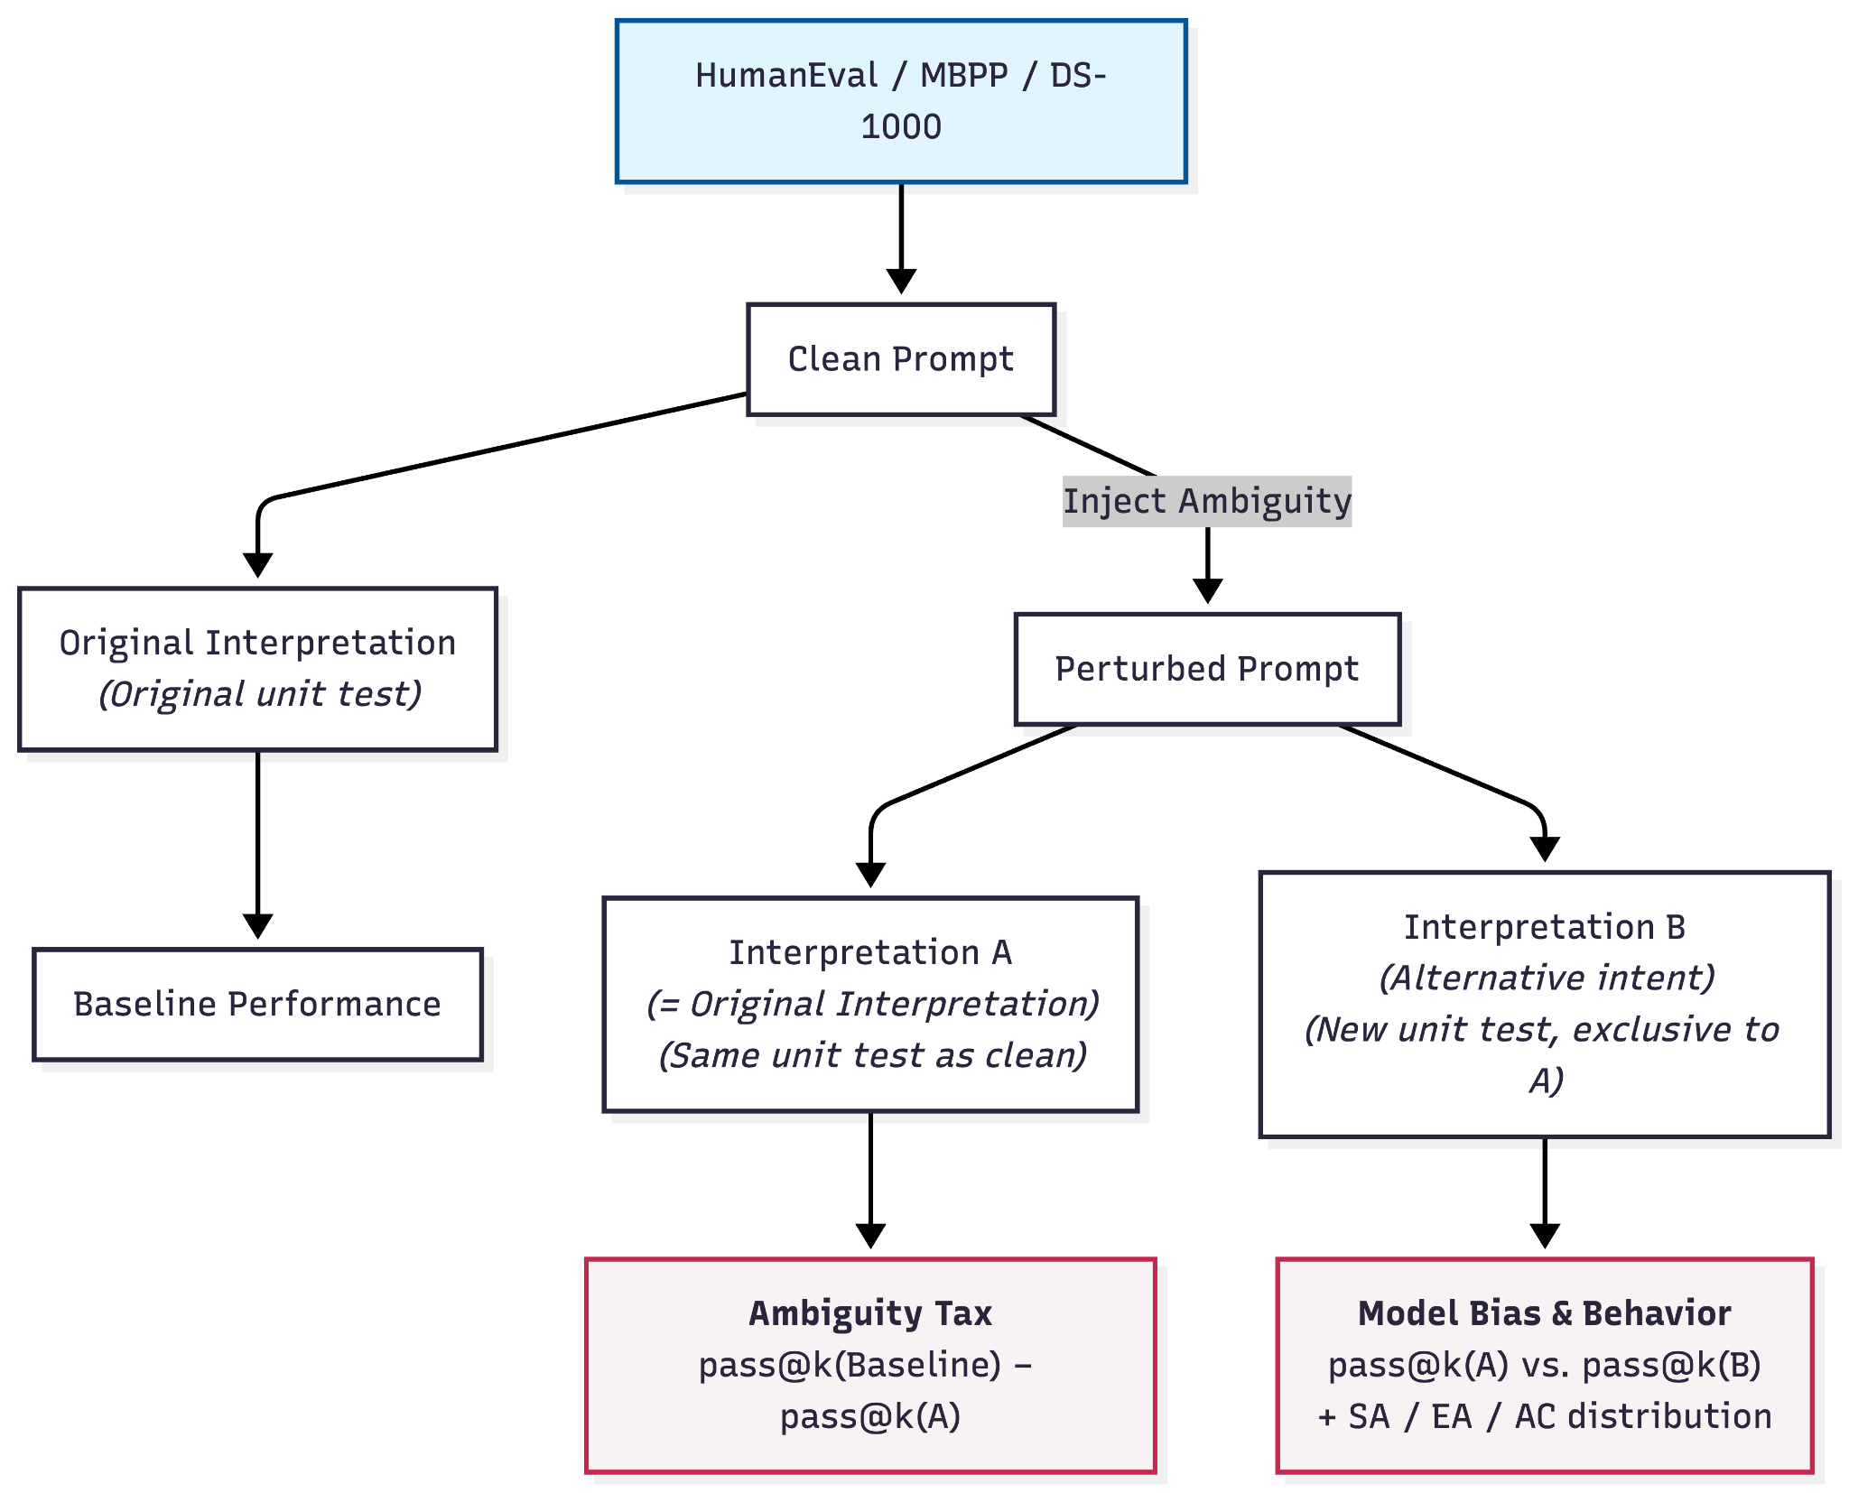
As shown in the diagram, to measure the cost of ambiguity directly, each task follows a clean-versus-perturbed design. Every ambiguous prompt (Perturbed) is paired with its original unambiguous anchor (Clean), allowing us to compute the Ambiguity Tax — the drop in pass@k attributable purely to ambiguity injection rather than task difficulty. Alongside this, each model response to the perturbed prompt is classified under the SA/EA/AC behavioral framework, providing the explanatory lens for where and why the accuracy loss occurs.

Related Work
- LLMs and Ambiguity in NLP. Liu et al. (2023) introduced the AmbiEnt dataset, showing that state-of-the-art models including GPT-4 fail to recognize natural language ambiguity, scoring 32% against 90% human accuracy. Li et al. (2024) established an 11-type linguistic ambiguity taxonomy for NLP tasks. We build on their taxonomy, porting its most code-disruptive types into the executable domain of code generation.
- Clarifying Questions in Open-Domain Settings. Prior work has studied training LLMs to ask clarifying questions when faced with ambiguous requests. Zhang et al. (2025) show that existing LLMs overwhelmingly presuppose a single interpretation rather than seeking clarification, attributing this to shortcomings in standard RLHF preference labeling. Our work extends this observation into code generation, where the cost of a wrong implicit assumption is mathematically verifiable through unit testing rather than subjectively assessed.
- HumanEvalComm. Most directly related is HumanEvalComm (Wu & Fard, 2025), which modifies HumanEval prompts to be ambiguous, inconsistent, or incomplete, finding that over 60% of Code LLM responses still generate code rather than seek clarification. Our work extends this in three key ways: (1) we introduce a controlled clean-versus-perturbed design that isolates accuracy degradation attributable purely to ambiguity, rather than confounding it with task difficulty; (2) we replace their binary code/clarify distinction with the three-way SA/EA/AC framework that captures Explicit Assumption as a pragmatically distinct behavior; and (3) we scope exclusively to linguistic ambiguity, separating it from inconsistency and incompleteness to produce cleaner behavioral hypotheses.

Evaluation
Metric 1 — Pragmatic Behavioral Distribution. For each model response to the perturbed prompt, an LLM-as-Judge classifies the response as SA, EA, or AC using a structured three-question boolean rubric, deriving the label deterministically rather than through free-form judgment. To prevent circular evaluation, a tested model is never used as its own judge. We report SA/EA/AC distributions stratified by ambiguity type and risk level.

Metric 2 — Ambiguity Tax & Conditional pass@k. All clean anchor responses are executed to establish pass@k(Baseline) per model per item. For perturbed SA/EA responses, dual-blind execution against both test suites produces pass@k(A) and pass@k(B). The Ambiguity Tax is defined as pass@k(Baseline) − pass@k(A), isolating accuracy degradation attributable purely to ambiguity injection. The asymmetry between pass@k(A) and pass@k(B) additionally reveals each model's inductive bias direction — which interpretation it defaults to when faced with ambiguity.

To ensure benchmark quality, every item must clear a two-stage quality gate before inclusion. Each clean anchor prompt is manually perturbed to inject one of the five ambiguity types, producing two mutually exclusive interpretations (A and B) with corresponding unit tests. Stage A is a mechanical sandbox check: both reference solutions are executed against both test suites, and the item passes only if the outcomes are strictly exclusive — Reference A passes Test-A and fails Test-B, and Reference B does the reverse. Stage B is an entropy-based annotation filter: five LLMs from distinct model families are asked to choose between the two interpretations via forced choice, and items where models converge too strongly on one reading (low entropy) are rejected as insufficiently ambiguous. Full pipeline details are provided in the Appendix: Details Pipeline, Phase 1.

Feasibility & Implementation Plan
Given the strict 6-week timeframe, the methodology is deliberately constrained to a micro-benchmark of 50 items utilizing the Anchor-and-Perturb strategy to avoid the bottleneck of writing unit tests from scratch.
- Models: SOTA LLMs across major families — GPT, Claude, Gemini, DeepSeek, Qwen — subject to compute budget.
- Computing Resources: API credits and Docker sandboxing for the Python evaluation suite.
6-Week Timeline:
- Week 1 (Data): Select 50 anchor tasks from HumanEval (Chen et al., 2021), MBPP (Austin et al., 2021), and DS-1000 (Lai et al., 2023). Perform manual/LLM-assisted perturbation to inject linguistic ambiguity across 5 types.
- Week 2 (Testing): Author 50 incremental Test-Perturbed unit tests and run the two-stage quality gate.
- Week 3 (Infrastructure): Build the LLM-as-Judge classification pipeline and dual-blind sandbox execution environment.
- Week 4 (Inference & Execution): Execute API calls with temperature sampling; run SA/EA/AC classification and conditional sandbox routing.
- Week 5 (Analysis): Compute Ambiguity Tax, behavioral distributions, and conditional pass@k; stratify by ambiguity type and risk level.
- Week 6 (Write-up): Finalize figures and project report.

Bibliography

[1] Liu et al., 2023 — AmbiEnt Liu, A., Wu, Z., Michael, J., Suhr, A., West, P., Koller, A., Swayamdipta, S., Smith, N. A., & Choi, Y. (2023). We're afraid language models aren't modeling ambiguity. In Proceedings of the 2023 Conference on Empirical Methods in Natural Language Processing (pp. 790–807). Association for Computational Linguistics. https://doi.org/10.18653/v1/2023.emnlp-main.51

[2] Li et al., 2024 — Ambiguity Taxonomy Li, M. Y., Liu, A., Wu, Z., & Smith, N. A. (2024). A taxonomy of ambiguity types for NLP. arXiv preprint arXiv:2403.14072. https://arxiv.org/abs/2403.14072

[3] Zhang et al., 2024 — Clarifying Questions Zhang, M. J. Q., Chhavi, T., & Dhingra, B. (2025). Modeling future conversation turns to teach LLMs to ask clarifying questions. In Proceedings of the 13th International Conference on Learning Representations (ICLR 2025). https://arxiv.org/abs/2410.13788

[4] Wu & Fard, 2025 — HumanEvalComm Wu, J. JW., & Fard, F. H. (2025). HumanEvalComm: Benchmarking the communication competence of code generation for LLMs and LLM agent. ACM Transactions on Software Engineering and Methodology, 34(7). https://doi.org/10.1145/3715109

[5] Chen et al., 2021 — pass@k / HumanEval Chen, M., Tworek, J., Jun, H., Yuan, Q., Pinto, H. P. de O., Kaplan, J., Edwards, H., Burda, Y., Joseph, N., Brockman, G., Ray, A., Puri, R., Krueger, G., Petrov, M., Khlaaf, H., Sastry, G., Mishkin, P., Chan, B., Gray, S., … Zaremba, W. (2021). Evaluating large language models trained on code. arXiv preprint arXiv:2107.03374. https://arxiv.org/abs/2107.03374

[6] Austin et al., 2021 — MBPP Austin, J., Odena, A., Nye, M., Bosma, M., Michalewski, H., Dohan, D., Jiang, E., Cai, C., Terry, M., Le, Q., & Sutton, C. (2021). Program synthesis with large language models. arXiv preprint arXiv:2108.07732. https://arxiv.org/abs/2108.07732

[7] Lai et al., 2023 — DS-1000 Lai, Y., Li, C., Wang, Y., Zhang, T., Zhong, R., Zettlemoyer, L., Yih, W., Fried, D., Wang, S., & Yu, T. (2023). DS-1000: A natural and reliable benchmark for data science code generation. In Proceedings of the 40th International Conference on Machine Learning (ICML 2023). https://arxiv.org/abs/2211.11501

Appendix
Detail Pipeline:
https://docs.google.com/document/d/1N_BRdLzRV2dfgRD-gDYwOIcwnfzTDnMy/edit?usp=drive_link&ouid=102161280272899476192&rtpof=true&sd=true
Ambiguity Definition & Example:
https://docs.google.com/document/d/1UbPRo07YJRTuVknFK6HV_CPaNOxWmpgK/edit?usp=sharing&ouid=102161280272899476192&rtpof=true&sd=true

